Annagh Hill N.S.
Special Edition Newsletter
June 2015

5K Run: The second Brooklodge 5K run took place on September 20th last. Our thanks to Joe and Kathleen Boyle for allowing us to use their premises in order to facilitate the run. Many thanks also to all of the organisers, all who participated, and all who gave sponsorship. A total of €1275.35 excluding expenses was raised.
Credit Union Quiz: Our U13 quiz team participated in Credit Union Quiz and won the first round. They competed in the second round in the Menlo Park Hotel on Sunday March 1st. While they did not come first, they acquitted themselves very well and enjoyed the experience.
.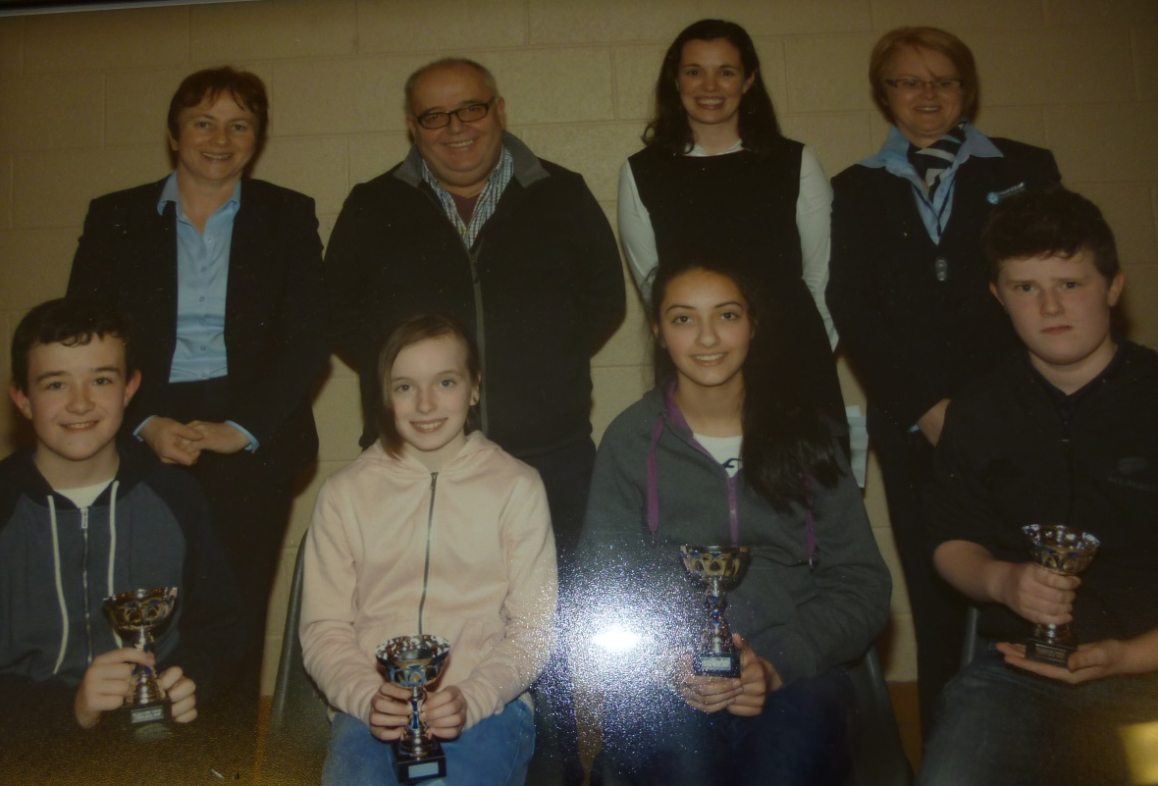
The team consisted of: Jason Lambert, Shane Farragher, Sarah McGowan and Medb McCarthy.
Our U11 team also competed in the Credit Union Quiz but unfortunately didn’t make it into the second round. Shauna O’Brien, Niamh Cannon, Eoghan Conneely and Jordan Coen did our school proud.
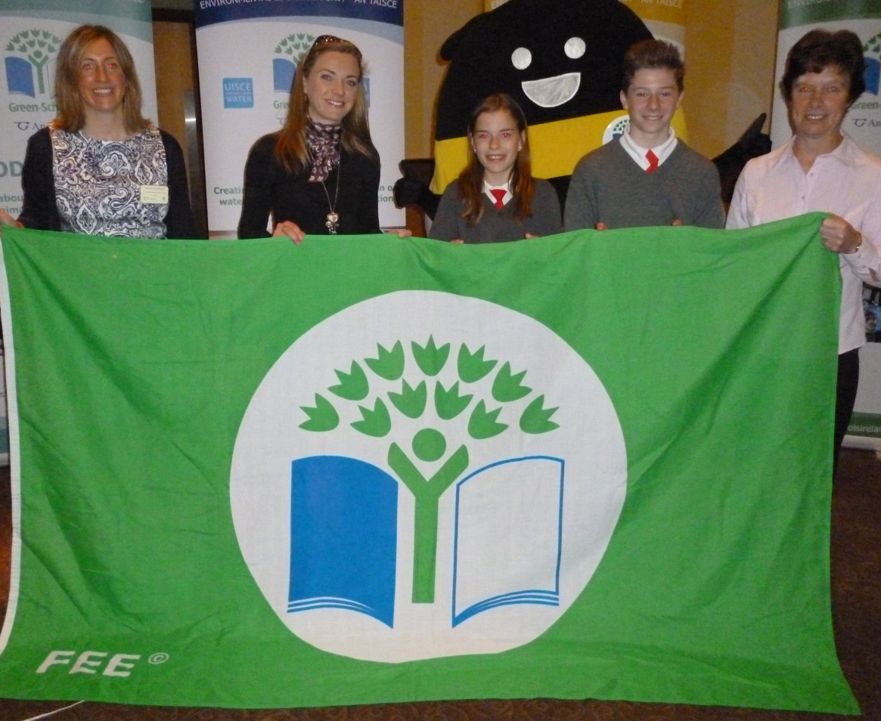
Green Schools Award: Our theme this year was Biodiversity. The Green Schools Award ceremony took place in the Radisson Hotel on Tuesday May 19th. Congratulations to the Green Schools committee (Jamie Collins, Ryan Jensen, Emma Harte Geasley, Jason Freaney, Sean Conolly and Roisín McCarthy) and co- ordinators Mrs. Hughes and Ms. Flynn, for their hard work in achieving the green flag for our school. Ms. Flynn, Mrs. Hughes, Roisín and Sean from 6th class attended the ceremony. We are very proud of Sean and Roisín as they represented our school extremely well. Kay Synott came to explain biodiversity in more detail to us too.

Green Flag Launch: On Tuesday 23rd June, we held a ceremony to raise our Green Flag. Newly elected County Galway Mayor Peter Roche performed the ceremony in glorious sunshine. Some parents also attended on the day in what was a memorable occasion for the school.

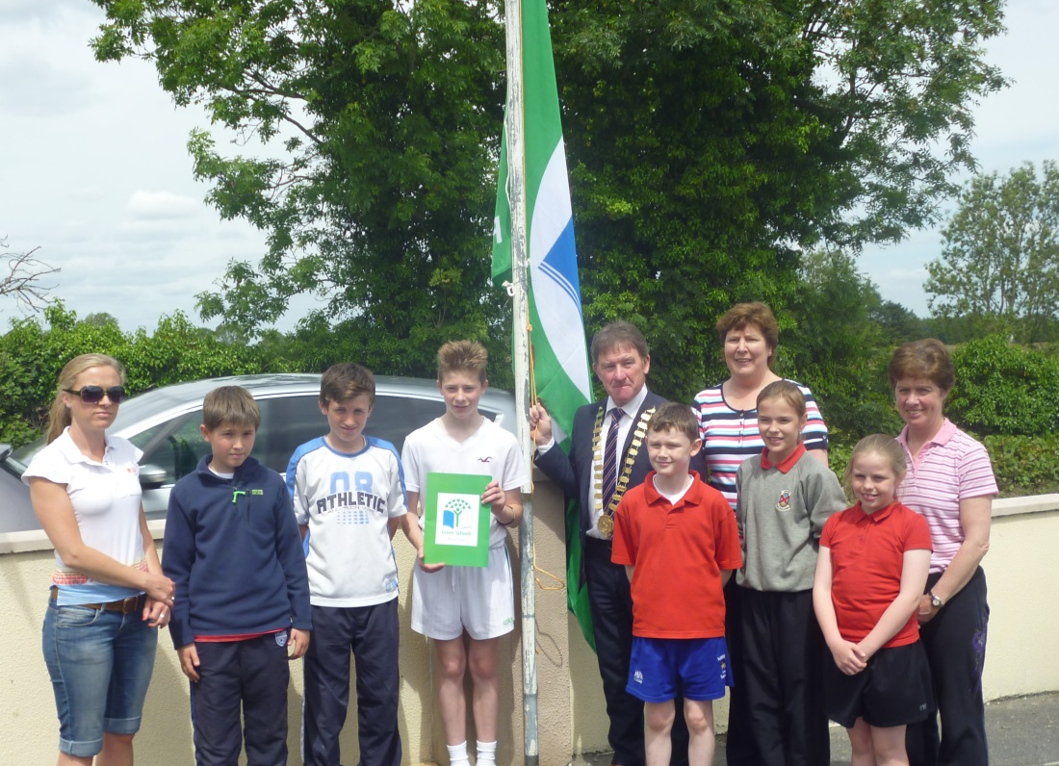
Sale of Work: The annual Christmas Sale of Work took place on the 7th December. It was a huge success and a very enjoyable day was had by all. An enormous amount of work went in to the organisation of the day, and great credit is due to all of the parents who contributed to this. Thank you also to all of the shops and businesses in Galway, Tuam, Athenry, Monivea, Lackagh, Corofin and Abbeyknockmoy who donated spot prizes for the event. The total raised on the day was ___ ______. We really enjoyed the penalty shootout, wheel of fortune, charity shop, hot food and shop and the raffle to mention just a few. Santa also visited on the day.

Open Day for Juniors: A very successful Open Day took place on Thursday February 12th. A power point presentation was shown to the parents while the perspective new pupils enjoyed time in one of the Junior classrooms. The parents were given a tour of the school, including a visit to all classrooms where they enjoyed singing, music and various other performances. Refreshments were served afterwards and the parents were then invited to visit ‘Little Hands’ Breakfast Club, Montessori and After School Care.

Little Hands Montessori /After School Care: We are lucky to have a breakfast and afterschool club, as well as a Montessori room within our school. It is there to cater for us before school starts and after school finishes as well as a pre-school for younger children.

The Mad Scientist & Puppet Show: To mark science week Jay the Mad Scientist visited our school on November 11th, we all thoroughly enjoyed a very interactive science workshop. He entertained us with experiments using air and weight distribution.

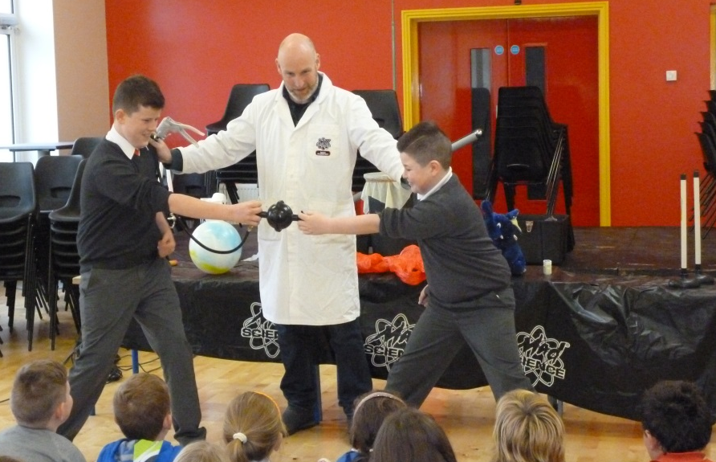
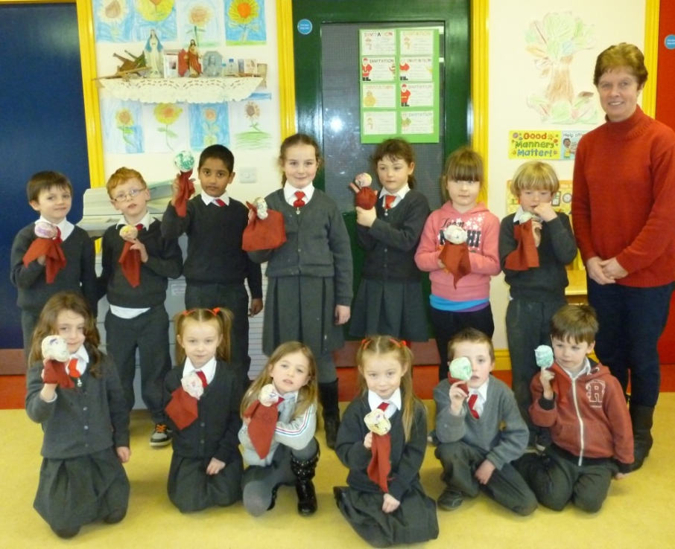

Jay returned to our school earlier this year and performed a puppet show. He also helped us to create our own puppet.

Sponsored Walk:
Our annual Sponsored Walk took place on 23rd June. Everyone took part including some past pupils who joined us on the day. We were fortunate to stunning weather which added to the occasion. As a treat we all got cones from the ice-cream van afterwards.

Christmas Concert: Congratulations to all the children who performed so well in their Christmas Concert on the evening of the 16th December. It was a wonderful night of entertainment and great credit is due to the pupils and teachers. Thanks to all the parents and staff who contributed in any way to make the occasion run so smoothly. The performances on the night included: A Farmer from Assisi (Junior & Senior Infants), A Zombie Christmas (1st & 2nd class), Are We There Yet ( 3rd & 4th class) and Mr. Humbug Sees The Light ( 5th & 6th class ) A big thank you to Fintan Higgins for the sound and to Martin Collins for making the stage at short notice.
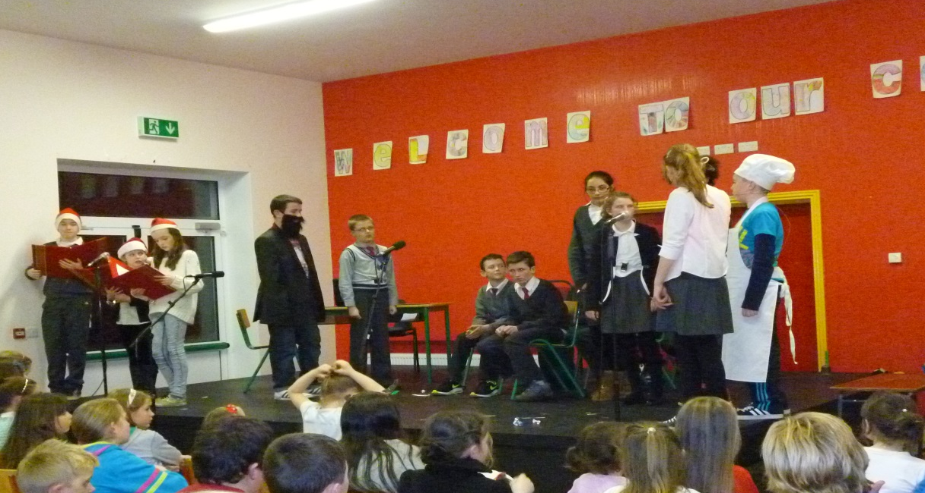

Brooklodge Nursing Home: On Wednesday Decemebr 17th, the third and fourth classes entertained the residents of Brooklodge Nursing Home with drama, gymnastics, singing, dancing and music.

Food Dudes: The Food Dude programme was run in our school earlier this year. A variety of fresh fruit and vegetables (carrot, raisins, banana, peppers, mandarins, mangetout and apple) were delivered to our school daily. We were all encouraged to eat these and there were some we had never eaten before.

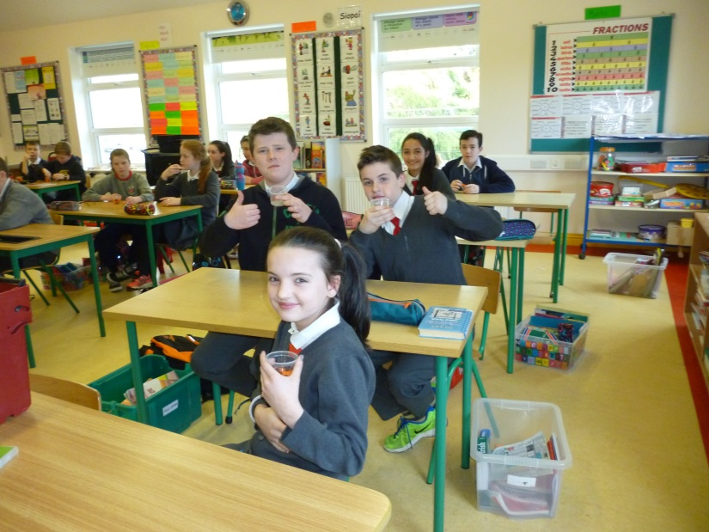
Skip-Hop: A Skip-Hop workshop took place in the school on Friday March 20th. All children were involved and thoroughly enjoyed the experience. We attempted many different skipping disciplines. At the end Mark McCabe and some other students entertained us with their skipping skills.

Scholastic Book Fair: A Scholastic Book Fair took place in the school from Monday May 25th until June 5th. We were all allowed to view the books and posters on display. Everyone got to purchase a book(s) of our choice. The school will receive 60% commission on books for the school.

Fun Days Out
School Tours: We have two school tours every year, a senior and a junior tour. This year the junior tour (which consists of junior infants –second class) went to NUIG to an indoor activity centre (Lets Go). They thoroughly enjoyed the day and had great fun. The senior tour, (3rd –6th class) went to Petersburg, Clonbur. We all got to do a land and a water based activity. We tried many new activities that we wouldn’t have experienced before such as gorge walking and abseiling. Everyone had a fantastic day and so did the teachers and staff.

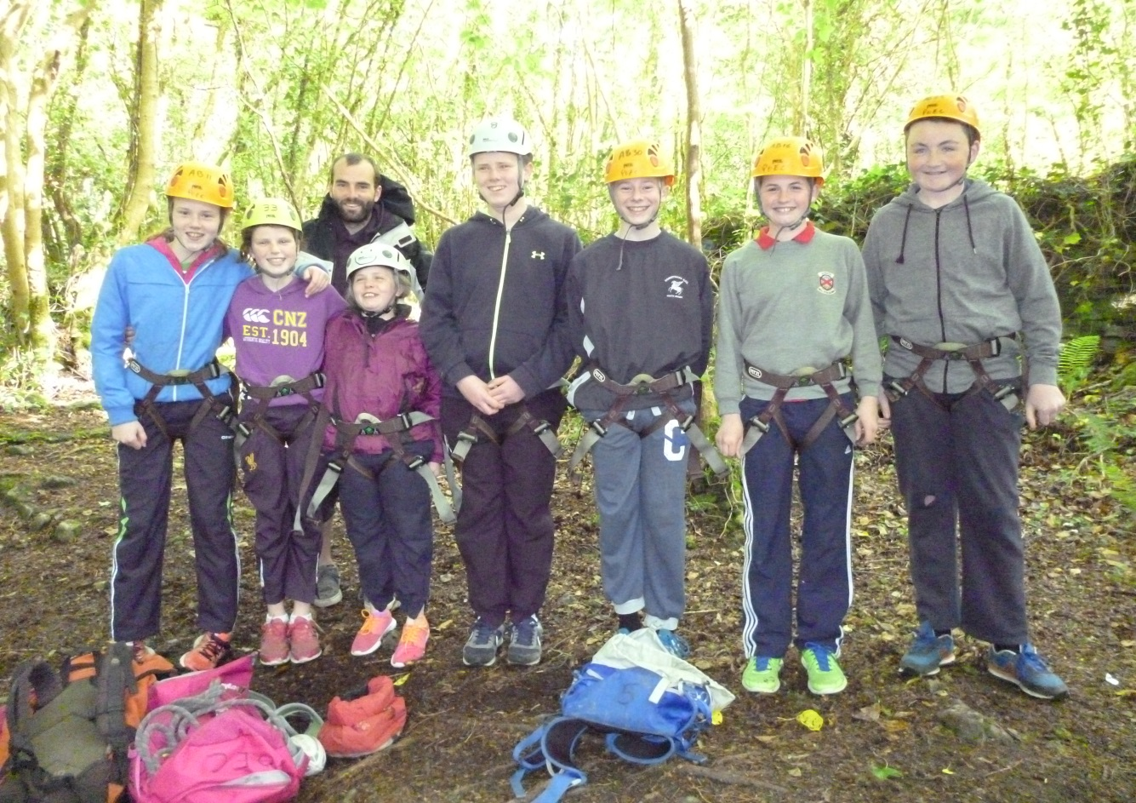
Bowling: On November 13th, the 5th and 6th classes availed of a free hour of bowling organised by City Limits Bowling, Oranmore. It was a very enjoyable outing.
Cross Fit Kids: On 2nd June, the 3rd & 4th classes were taken on a complimentary trip to Cross Fit Kids, an Oranmore based fitness centre run by Tom & Claudia French. They got to try fun workouts and fitness activities. They had a super time.

Charity Events:
Alzheimer’s Tea Day: Thanks to all who contributed to the Alzheimer’s Tea day and many thanks to Mary Hynes who donated enough buns for every child in the school as she does every year. The total raised by the school on the day was _________________. All the children and staff look forward to the buns each year.
Blue Day for Autism: A ‘Blue Day for Autism’ was held in the school on Tuesday May 26th. All children wore something blue on the day and donated €2 to the G.A.P.(Galway Autism Partnership). This was great fun and a brilliant way to raise money for a worthy charity.
Saving Grace: Grace is an 11 yr old girl who suffers from a rare form of cancer. During our Sale of Work we sold some second hand toys and books to raise funds for the Saving Grace Foundation. A total of €160.00 was raised on the day.
Christmas Shoe Box Appeal: A big thank you to all of the children who brought in shoe boxes for the Christmas Shoe Box Appeal.
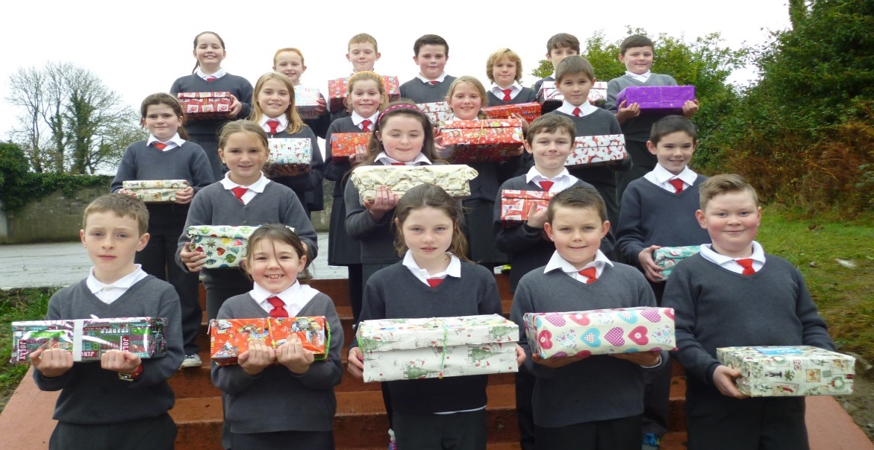

The Sacraments: Congratulations to the 2nd class children on receiving the sacrament of Penance on Thursday March 12th. Thanks to Mr. Greaney and Mrs. Grealish for their work in preparing the children for these sacraments.
The second class children received the sacrament of the Eucharist on Saturday May 16th in Brooklodge Church. Sincere thanks to Mrs. Grealish and Fr. Howley for making this day so memorable for the children.
Our 6th class boys and girls received the sacrament of Confirmation on Friday March 6th. It was a very special ceremony. Sincere thanks to all involved.

Sports Day: On the 12th of June sports day took place in our school. We were fortunate to have suitable weather for this occasion. We did lots of different activities such as balloon bursting, penalty shootout, sack race, tug-o-war and lots more. We had a fantastic day.

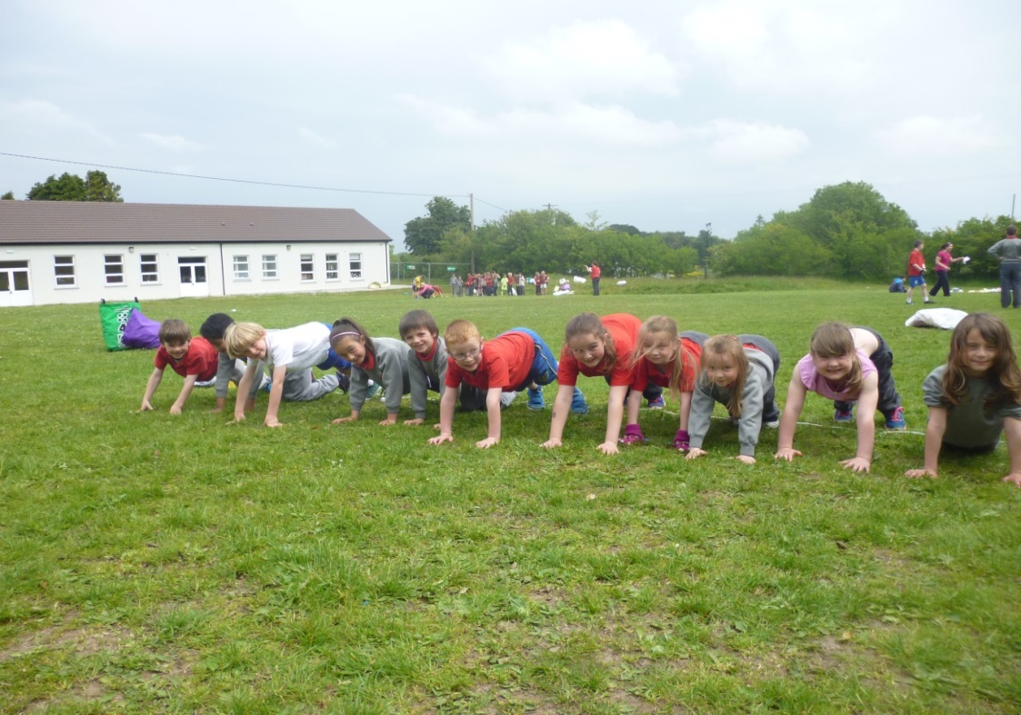

After School Activities: Every Wednesday after school the children from 4th to 6th class take part in a French programme. It is run by Anne McCarthy and has given us a great head start for secondary school. We have art class after school every Tuesday . This is run by Orla (Orla’s Art). She has helped us develop our creativity and love of art with her amazing ideas.

Facebook
Please keep up to date on news and events taking place in our school on our Facebook page.

Sport in Annagh Hill
Raftery Cup: We entered two teams into the Raftery Cup this year for the first time. Our 7-a-side team won the inaugural Raftery Cup Plate following an impressive win over Cummer. Our 9-a-side team failed to qualify for the Raftery Cup Final following narrow defeats to Cummer and Ballinderry. We contested the Raftery Cup Shield Final against Belclare and were victorious in what was a hard fought match. Well done to both teams.

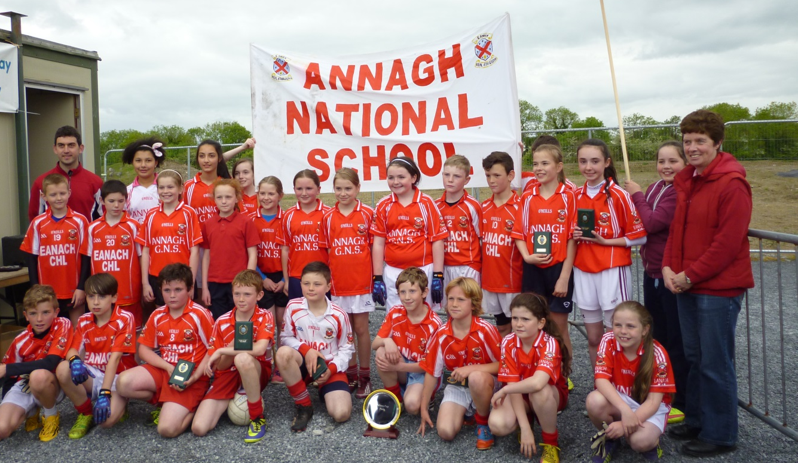

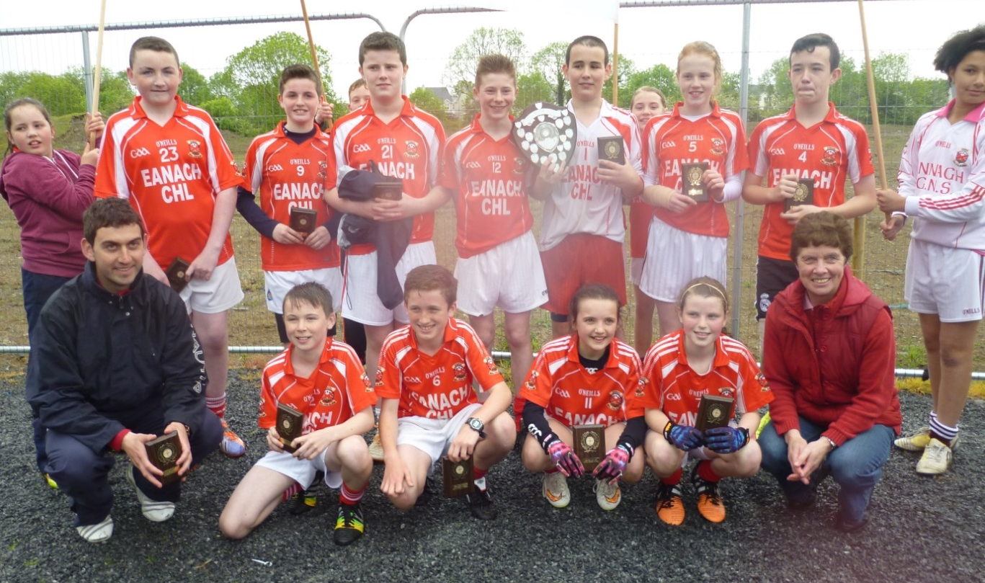

Cumann na mBunscol – Hurling: The boys travelled to Coolarne on May 6th to compete in their Cumann na mBunscol 11-a-side hurling blitz. A victory over Bawnmore and two narrow defeats against Coolarne and Coldwood meant that we didn’t do enough to qualify for the final but the boys can be very proud of themselves.

Cumann na mBunscol – Boys Football: We competed in the Boys Cumann na mBunscol 9-a-side football blitz on May 11th in Coolarne. We had victories over both Coolarne and Corrandrum but a defeat to Crumlin by a single point failed to see us qualify for the final.

Cumann na mBunscol – Girls Football: On May 20th, the girls competed in their 9-a-side football blitz in Caherlistrane. They defeated Cloughanover, Headford, Kilcoona and Cahergal following some great football. This saw us qualify for the Cumann na mBunscol Roinn F final against Corrandrum. This match was played on June 8th in Lackagh. The match was level at full time and after two periods of extra time we were unfortunately defeated by a point on a scoreline of 1-9 to 2-5. We are all very proud of their efforts.

Nicholson Cup / Patricia Kelly Memorial Cup: The boys and girls from Crumlin / Annagh Hill competed in both the Nicholson Cup and Patricia Kelly Memorial competitions again this year. Both teams qualified for their respective finals and these were played on June 15th in Monivea. The girls put on a great display to overcome Monivea and capture the Patricia Kelly Memorial Cup. The boys also showed great determination to win the Nicholson Cup again, against a gallant Monivea side. Congratulations to all involved.

Archbishop McHale – Soccer The annual Archbishop McHale soccer tournament was held at the Tuam Celtic F.C. grounds on Friday, May 8th. The boys and girls braved terrible weather conditions to make it all the way to their respective finals. Both the girls’ and boys’ final were contested between Annagh Hill and Kilconly. Kilconly came out on top in both games but it was a great achievement to reach both finals.

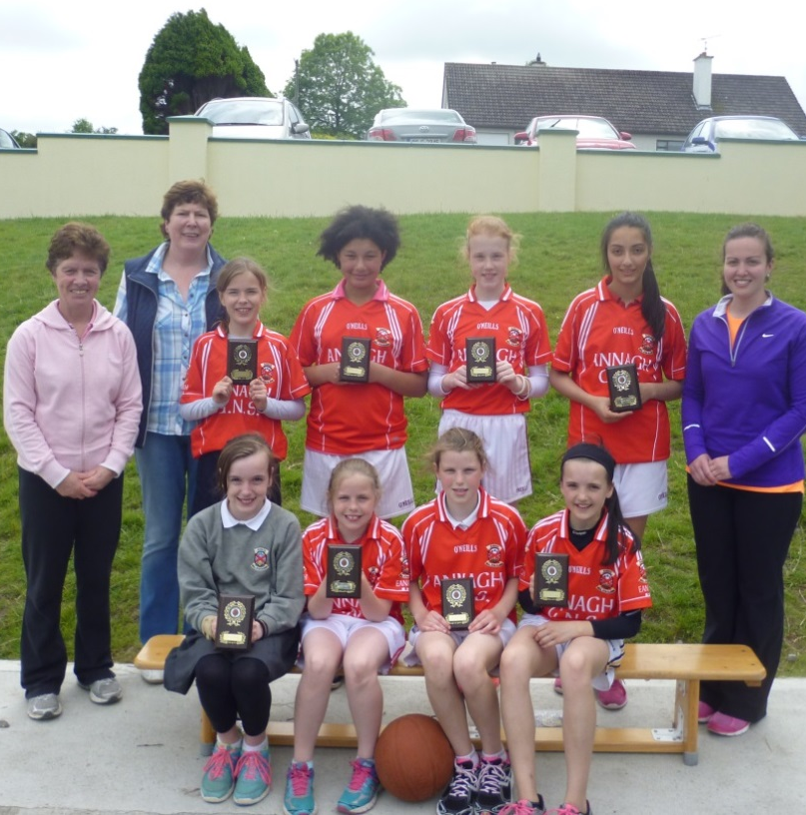
Treacy Cup – BasketballOn Wed 17th May, 5th & 6th class girls contested the Treacy Cup in Belclare. In what was a brilliant display of basketball the girls defeated teams from Cummer, Ballinderry, Castlehackett and Belclare and were outstanding winners of the Treacy Cup. This was the last competitive sporting event and was a perfect end to an amazing year of sport in our school.

Graduation Mass & Awards: On the 11th of June students from 6th class celebrated their graduation mass. It was also our end of year mass. Fr. Mullins was the celebrant of the mass and wished us all well in the future. After the mass 6th class had an award ceremony where we received a graduation certificate and plaque in recognition of our time spent in Annagh Hill N.S. Shortly after we enjoyed a party with some family members. 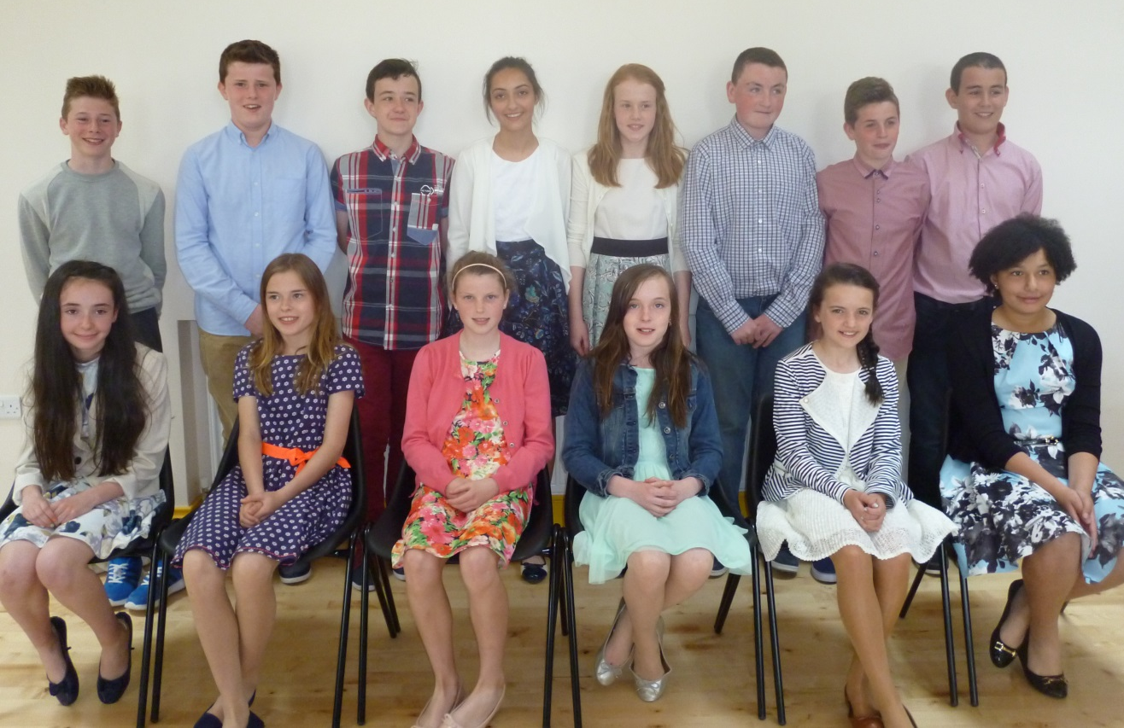

Teachers & Staff: We would to thank all our teachers and staff for their hard work and dedication during our time spent Annagh Hill N.S., and we now feel we are ready for the next step in our lives – secondary school.

Mrs Flaherty (principal)
Ms Flynn (deputy principal)
Mrs Hughes
Mr Greaney
Mr Grealish
Ms Heneghan
Ms Ryan

Nora (secretary)
Dan (care taker)
Breda (SNA)

