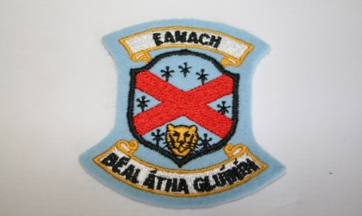
Annagh Hill N.S.
ANNUAL ADMISSION NOTICE
in respect of admissions to the 2021/2022 school year

Admission Policy and Application Form
A copy of the school’s Admission Policy and the Application Form for Admission for the 2021/2022 is available as follows: –
To download at: www.annagh-hillns.ie
On request: By emailing info@annagh-hillns.ie or writing to Annagh Hill N.S., Ballyglunin, Tuam, Co. Galway

PART 1 - Admissions to the 2021/2022 school year

Application and Decision Dates for admission to 2021/2022
The following are the dates applicable for admission to Junior Infants

The school will commence accepting applications for admission on | 30/11/2020
The school shall cease accepting applications for admission on | 30/04/2021
The date by which applicants will be notified of the decision on their application is | 20/05/2021
The period within which applicants must confirm acceptance of an offer of admission is | 31/05/2021

Note: the school will consider and issue decisions on late applications in accordance with the school’s admission policy.

*Failure to accept an offer within the prescribed period above may result in the offer being withdrawn
Number of places being made available in 2021/2022

The number of places being made available in junior infants is | 14
The number of residential places is (boarding schools only) | N/A
The number of non-residential places is (boarding schools only) | N/A
The number of places being made available in the special class* catering for children with [insert category or categories of SEN catered for in the special class] is | N/A

